# Developer Environment Setup Assignment

## 1. Operating System

OS: Windows 11  
Download Link: <https://www.microsoft.com/software-download/windows11>

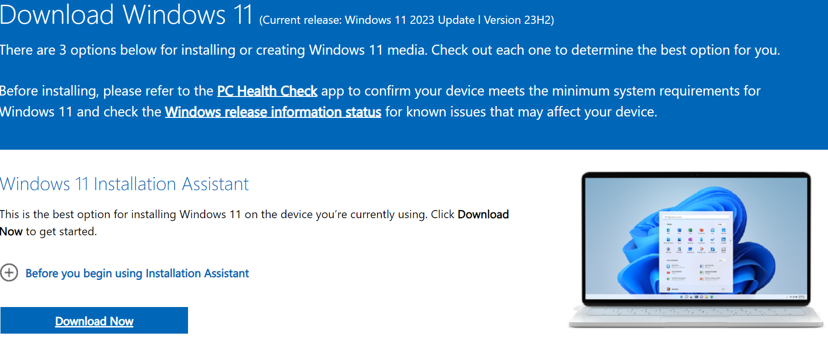

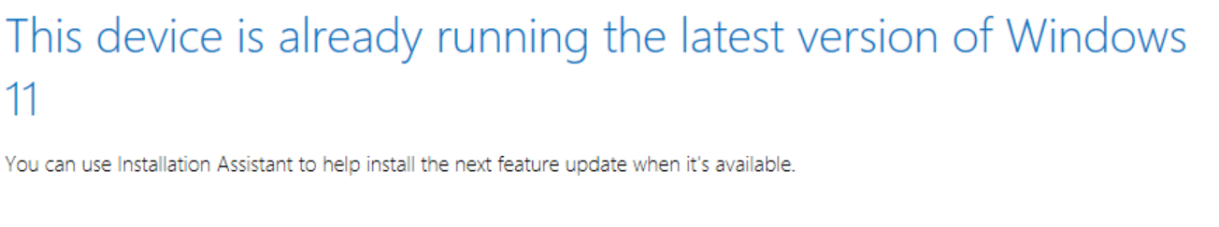**2. Text Editor/IDE**

IDE: Visual Studio Code  
Download Link: <https://code.visualstudio.com/Download>

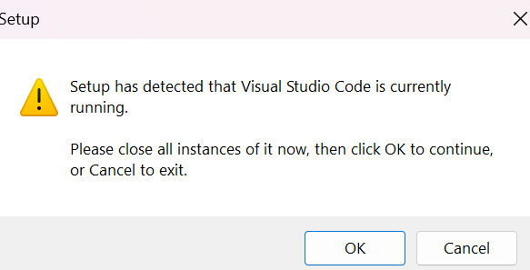

## 3. Version Control System

Git: Installed from https://git-scm.com/downloads  
GitHub Account: Created at https://github.com  
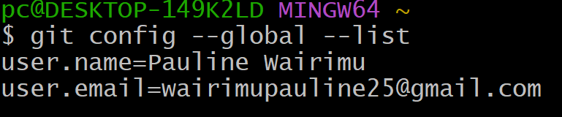

## 4. Extensions and Plugins

VS Code Extensions: Installed from https://marketplace.visualstudio.com/VSCode  
- Python Extension: Adds support for Python development.  
- Git Lens: Enhances Git capabilities.  
- Prettier - Code formatter: Formats code consistently

**5.MySQL Installation**

